Project Proposal

On

Blood Bank and Donor Management System

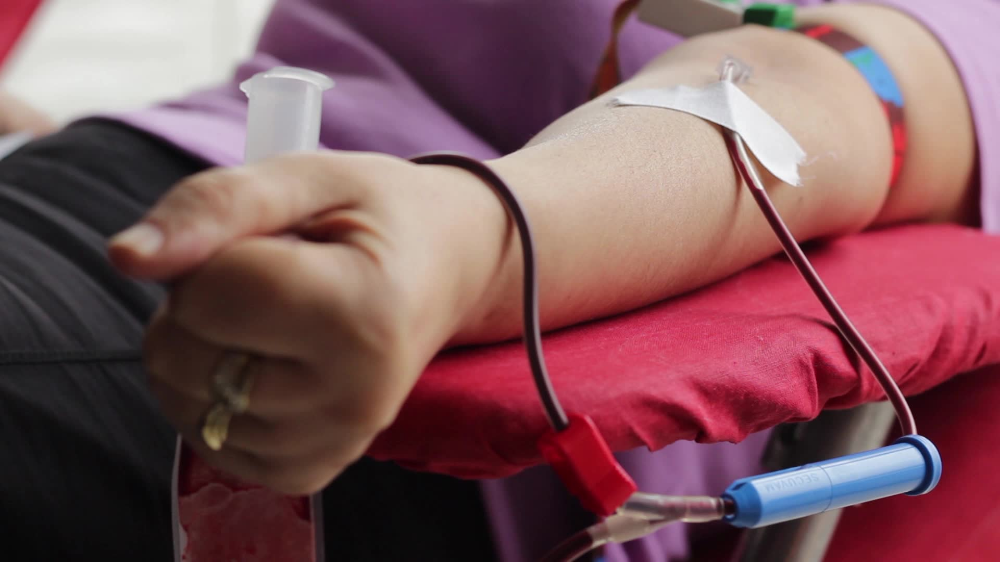

Sabin Gautam

00175013

Computing Project

Level 5 in Computing

Softwarica College of IT and E-Commerce

Kathmandu, Nepal

April 7th 2019

Submitted to: Niman Maharjan